Practical lesson 19 : Microbiological diagnostics of protozooses
Parasitology

Parasites occur in two distinct forms: single-celled protozoa and multicellular metazoa called helminths or worms. For medical purposes, protozoa can be subdivided into four groups: Sarcodina (amebas), Sporozoa (sporozoans), Mastigophora (flagellates), and Ciliata (ciliates). Metazoa are subdivided into two phyla: the Platyhelminthes (flatworms) and the Nemathelminthes (roundworms, nematodes). The phylum Platyhelminthes contains two medically important classes: Cestoda (tapeworms) and Trematoda (flukes).

INTESTINAL PROTOZOA
ENTAMOEBA
Entamoeba histolytica causes amebic dysentery and liver abscess.
Important Properties
The life cycle has two stages: the motile ameba (trophozoite) and the nonmotile cyst . The trophozoite is found within the intestinal and extraintestinal lesions and in diarrheal stools. The cyst predominates in nondiarrheal stools. These cysts are not highly resistant and are readily killed by boiling but not by chlorination of
water supplies. They are removed by filtration of water. The cyst has four nuclei, an important diagnostic criterion. Upon excystation in the intestinal tract, an ameba with four nuclei emerges and then divides to form eight trophozoites. The mature trophozoite has a single nucleus with an even lining of peripheral chromatin and a prominent central nucleolus (karyosome). Antibodies are formed against trophozoite antigens in
invasive amebiasis, but they are not protective; previous infection does not prevent reinfection. The antibodies are useful, however, for serologic diagnosis.
Laboratory Diagnosis
Diagnosis of intestinal amebiasis rests on finding either trophozoites in diarrheal stools or cysts in formed stools. Diarrheal stools should be examined within 1 hour of collection to see the ameboid motility of the trophozoite. Trophozoites characteristically contain ingested red blood cells. The most common error is to mistake fecal leukocytes for trophozoites. Because cysts are passed intermittently, at least three specimens should be examined. The O&P test is insensitive and false negatives commonly occur. Also, about half of the patients with extraintestinal amebiasis have negative stool examinations. Entamoeba histolytica can be distinguished from other amebas by two major criteria: (1) The first is the nature of the nucleus of the trophozoite. The E. histolytica nucleus has a small central nucleolus and fine chromatin granules along the border of the nuclear membrane. The nuclei of other amebas are quite different. (2) The second is cyst size and number of its nuclei. Mature cysts of E. histolytica are smaller than those of Entamoeba coli and contain four nuclei, whereas E. coli cysts have eight nuclei. The trophozoites of Entamoeba dispar, a nonpathogenic species of Entamoeba, are morphologically indistinguishable from those of E. histolytica; therefore, a person who has trophozoites in the stool is only treated if symptoms warrant it. Two tests are highly specific for E. histolytica in the stool: one detects E. histolytica antigen, and the other detects nucleic acids of the organism in a polymerase chain reaction (PCR)-based assay.
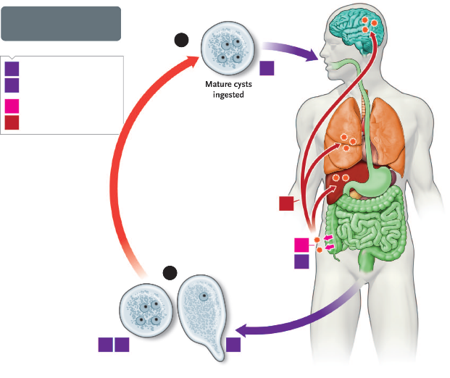
Entamoeba histolytica. Life cycle. Top blue arrow shows cysts being ingested. Within the intestine, the cyst produces trophozoites that cause amebic dysentery in the colon and can spread to the liver (most often), lung, and brain (Boxes A and B). Bottom blue arrow shows cysts and trophozoites being passed in the stool and entering the environment. Red arrow indicates survival of cysts in the environment.

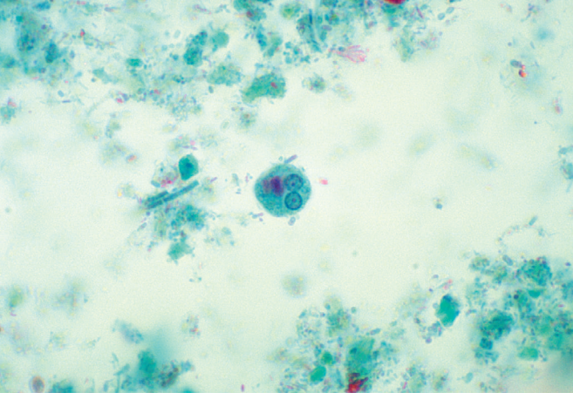
Entamoeba histolytica—cyst. Arrow points to a cyst of E. histolytica. Two of the four nuclei are visible just to the left of the head of the arrow.
Treatment
The treatment of choice for symptomatic intestinal amebiasis or hepatic abscesses is metronidazole (Flagyl) or tinidazole. Hepatic abscesses need not be drained. Asymptomatic cyst carriers should be treated with iodoquinol or paromomycin.
Prevention
Prevention involves avoiding fecal contamination of food and water and observing good personal hygiene such as handwashing. Purification of municipal water supplies is usually effective, but outbreaks of amebiasis in city dwellers still occur when contamination is heavy. The use of “night soil” (human feces) for fertilization of crops should be prohibited. In areas of endemic infection, vegetables should be сooked.
GIARDIA
Giardia lamblia causes giardiasis. The trophozoite is pearshaped with two nuclei, four pairs of flagella, and a suction disk with which it attaches to the intestinal wall. The oval cyst is thick-walled with four nuclei and several internal fibers. Each cyst gives rise to two trophozoites during excystation in the intestinal tract.
Pathogenesis & Epidemiology
Transmission occurs by ingestion of cysts in fecally contaminated food and water. Excystation takes place in the duodenum, where the trophozoite attaches to the gut wall but does not invade the mucosa and does not enter the bloodstream. The trophozoite causes inflammation of the duodenal mucosa, leading to malabsorption of protein and fat. The organism is found worldwide; about 5% of stool specimens in the United States contain Giardia cysts. Approximately half of those infected are asymptomatic carriers who continue to excrete the cysts for years. IgA deficiency greatly predisposes to symptomatic infection.
Clinical Findings
Watery (nonbloody), foul-smelling diarrhea is accompanied by nausea, anorexia, flatulence, and abdominal cramps persisting for weeks or months. There is no fever.
Laboratory Diagnosis
Diagnosis is made by finding trophozoites or cysts or both in diarrheal stools. In formed stools (e.g., in asymptomatic carriers), only cysts are seen. An enzymelinked immunosorbent assay (ELISA) test that detects Giardia antigen in the stool is also very useful. Tests for antibody in the serum are not routinely available. If those tests are negative and symptoms persist, the string test, which consists of swallowing a weighted piece of string until it reaches the duodenum, may be useful. The trophozoites adhere to the string and can be visualized after withdrawal of the string.
Treatment
The treatment of choice is either tinidazole (Tinidamax) or metronidazole (Flagyl). Tinidazole is better tolerated.
Prevention
Prevention involves drinking boiled, filtered, or iodinetreated water in endemic areas and while hiking. No prophylactic drug or vaccine is available.
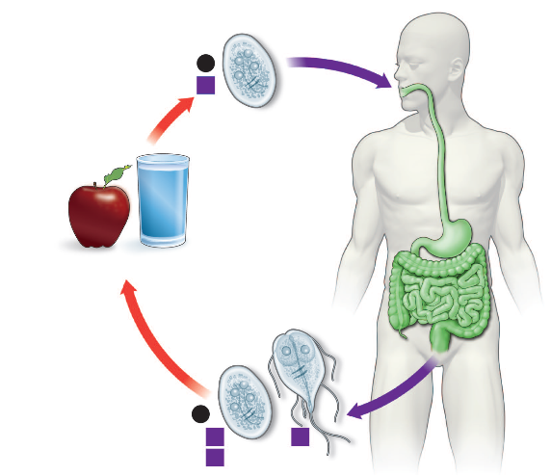
Giardia lamblia. Life cycle. Top blue arrow shows cysts being ingested. Within the intestine, the cyst produces trophozoites that cause diarrhea. Bottom blue arrow shows cysts and trophozoites being passed in the stool and entering the environment. Red arrow indicates survival of cysts in the environment.

CRYPTOSPORIDIUM
Disease
Cryptosporidium hominis causes cryptosporidiosis, the main symptom of which is diarrhea. The diarrhea is most severe in immunocompromised patients (e.g., those with acquired immunodeficiency syndrome [AIDS]). Cryptosporidium parvum is the former name that is no longer used.
Important Properties
Some aspects of the life cycle remain uncertain, but the following stages have been identified. Oocysts release sporozoites, which form trophozoites. Several stages ensue, involving the formation of schizonts and merozoites. Eventually microgametes and macrogametes form; these unite to produce a zygote, which differentiates into an oocyst. This cycle has several features in common with other sporozoa (e.g., Isospora). Taxonomically, Cryptosporidium is in the subclass Coccidia.

Clinical Findings
The disease in immunocompromised patients presents primarily as a watery, nonbloody diarrhea causing large fluid loss. Symptoms persist for long periods in immunocompromised patients, whereas they are self-limited in immunocompetent patients. Although immunocompromised patients usually do not die of cryptosporidiosis, the fluid loss and malnutrition are severely debilitating.
Laboratory Diagnosis
Diagnosis is made by finding oocysts in fecal smears when using a modified Kinyoun acid-fast stain. A test for Cryptosporidium antigen in the stool is also useful.
Treatment & Prevention
Nitazoxanide is the drug of choice for patients not infected with human immunodeficiency virus (HIV). There is no effective drug therapy for severely immunocompromised patients, but paromomycin may be useful in reducing diarrhea. There is no vaccine or other specific means of prevention. Purification of the water supply, including filtration to remove the cysts, which are resistant to the chlorine used for disinfection, can prevent cryptosporidiosis
UROGENITAL PROTOZOA
TRICHOMONAS
Trichomonas vaginalis causes trichomoniasis.
Important Properties
Trichomonas vaginalis is a pear-shaped organism with a central nucleus and four anterior flagella. It has an undulating membrane that extends about two-thirds of its length. It exists only as a trophozoite; there is no cyst form.
Pathogenesis & Epidemiology
The organism is transmitted by sexual contact, and hence there is no need for a durable cyst form. The primary locations of the organism are the vagina and the prostate. It is found only in humans; there is no animal reservoir. Trichomoniasis is one of the most common infections worldwide. Roughly 25% to 50% of women in the United States harbor the organism. The frequency of symptomatic disease is highest among sexually active women in their thirties and lowest in postmenopausal women. Asymptomatic infections are common in both men and women.
Clinical Findings
In women, a watery, foul-smelling, greenish vaginal discharge accompanied by itching and burning occurs. Infection in men is usually asymptomatic, but about 10% of infected men have urethritis.
Laboratory Diagnosis
In a wet mount of vaginal discharge, the pear-shaped trophozoites have a typical jerky motion .Neutrophils are often seen in the fluid. There is no serologic Test.
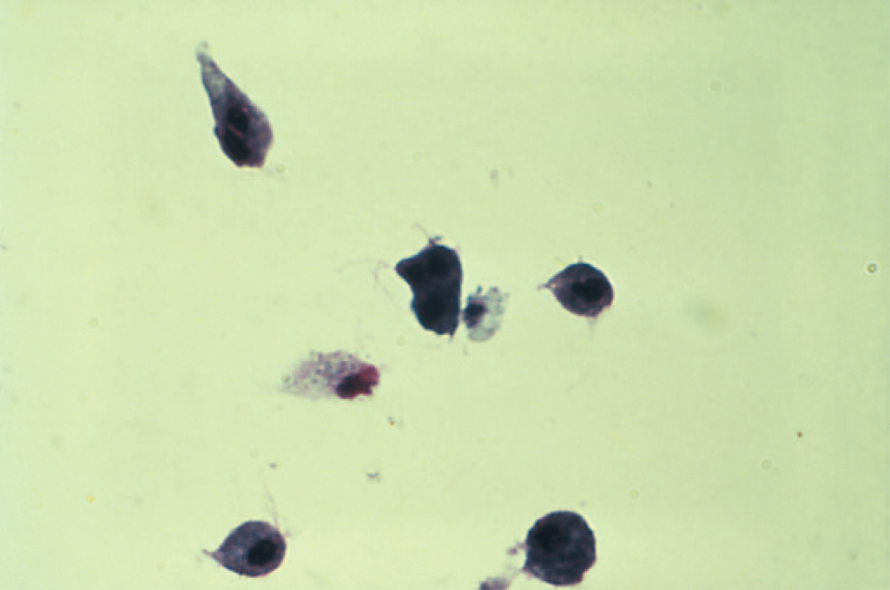
Trichomonas vaginalis

Treatment & Prevention
The treatment of choice is either tinidazole (Tinidamax) or metronidazole (Flagyl) for both partners to prevent reinfection. Tinidazole is better tolerated. Maintenance of the low pH of the vagina is helpful. Condoms limit transmission. No prophylactic drug or vaccine is available.
BLOOD& TISSUE PROTOZOA

PLASMODIUM
Malaria is caused primarily by four plasmodia: Plasmodium vivax, Plasmodium ovale, Plasmodium malariae, and Plasmodium falciparum. Plasmodium vivax and P. falciparum are more common causes of malaria than are P. ovale and P. malariae. Plasmodium vivax is most widely distributed and P. falciparum causes the most serious disease. A fifth species, Plasmodium knowlesi, is found in Southeast Asia. Worldwide, malaria is one of the most common infectious diseases and one of the leading causes of death.
Important Properties
The vector and definitive host for plasmodia is the female Anopheles mosquito (only the female takes a blood meal). There are two phases in the life cycle: the sexual cycle, which occurs primarily in mosquitoes, and the asexual cycle, which occurs in humans, the intermediate hosts.1 The sexual cycle is called sporogony because sporozoites are produced, and the asexual cycle is called schizogony because schizonts are made. The life cycle in humans begins with the introduction of sporozoites into the blood from the saliva of the biting mosquito. The sporozoites are taken up by hepatocytes within 30 minutes. This “exoerythrocytic” phase consists of cell multiplication and differentiation into merozoites. Plasmodium vivax and P. ovale produce a latent form (hypnozoite) in the liver; this form is the cause of relapses seen with vivax and ovale malaria. Merozoites are released from the liver cells and infect red blood cells. During the erythrocytic phase ,the organism differentiates into a ringshaped trophozoite. The sexual cycle begins in the human red blood cells when some merozoites develop into male and others into female gametocytes . The gametocyte-containing red blood cells are ingested by the female Anopheles mosquito and, within her gut, produce a female macrogamete and eight spermlike male microgametes. After fertilization, the diploid zygote differentiates into a motile ookinete that burrows into the gut wall, where it grows into an oocyst within which many haploid sporozoites are produced. The sporozoites are released and migrate to the salivary glands, ready to complete the cycle when the mosquito takes her next blood meal. A very important feature of P. falciparum is chloroquine resistance. Chloroquine-resistant strains now predominate in most areas of the world where malaria is endemic. Chloroquine resistance is mediated by a mutation in the gene encoding the chloroquine transporter in the cell membrane of the organism.
Laboratory Diagnosis
Diagnosis rests on microscopic examination of blood, using both thick and thin Giemsa-stained smears. The thick smear is used to screen for the presence of organisms, and the thin smear is used for species identification. It is important to identify the species because the treatment of different species can differ. Ring-shaped trophozoites can be seen within infected red blood cells.The gametocytes of P. falciparum are crescent-shaped (“banana-shaped”), whereas those of the other plasmodia are spherical. If more than 5% of red blood cells are parasitized, the diagnosis is usually P. falciparum malaria. Plasmodium species typically produce hemozoin pigment in infected red blood cells whereas Babesia species do not. Plasmodia metabolize heme in the red cells to produce hemozoin. Also found within P. vivax and P. ovale-infected red cells are Schüffner’s dots. These are intracytoplasmic granules that stain red using the Romanovsky stain. If blood smears do not reveal the diagnosis, then a polymerase chain reaction (PCR)-based test for Plasmodium nucleic acids or an enzyme-linked immunosorbent assay (ELISA) test for a protein specific for P. falciparum can be useful.
Treatment
The main criteria used for choosing specific drugs are the severity of the disease and whether the organism is resistant to chloroquine. Chloroquine resistance is determined by the geographical location where the infection was acquired rather than by laboratory testing. Chloroquine is the drug of choice for treatment of uncomplicated malaria caused by non-falciparum species in areas without chloroquine resistance. Chloroquine kills the merozoites, thereby reducing the parasitemia, but does not affect the hypnozoites of P. vivax and P. ovale in the liver. These are killed by primaquine, which must be used to prevent relapses. Primaquine may induce severe hemolysis in those with G6PD deficiency, so testing for this enzyme should be done before the drug is given. Primaquine should not be given if the patient is severely G6PD deficient. If primaquine is not given, one approach is to wait to see whether symptoms recur and then treat with chloroquine.

Prevention
Chemoprophylaxis of malaria for travelers to areas where chloroquine-resistant P. falciparum is endemic consists of mefloquine or doxycycline. A combination of atovaquone and proguanil (Malarone), in a fixed dose, can also be used. Chloroquine should be used in areas where P. falciparum is sensitive to that drug. Travelers to areas where the other three plasmodia are found should take chloroquine starting 2 weeks before arrival in the endemic area and continuing for 4 weeks after leaving the endemic area. This should be followed by a 2-week course of primaquine if exposure was high. Primaquine will kill the hypnozoites of P. vivax and P. ovale.

TOXOPLASMA
Toxoplasma gondii causes toxoplasmosis, including congenital toxoplasmosis.
Important Properties
The definitive host is the domestic cat and other felines; humans and other mammals are intermediate hosts. Infection of humans begins with the ingestion of cysts in undercooked meat or from accidental contact with cysts in cat feces. In the small intestine, the cysts rupture and release forms that invade the gut wall, where they are ingested by macrophages and differentiate into rapidly multiplying trophozoites (tachyzoites), which kill the cells and infect other cells. Cell-mediated immunity usually limits the spread of tachyzoites, and the parasites enter host cells in the brain, muscle, and other tissues, where they develop into cysts in which the parasites multiply slowly. These forms are called bradyzoites. These tissue cysts are both an important diagnostic feature and a source of organisms when the tissue cyst breaks in an immunocompromised patient. The cycle within the cat begins with the ingestion of cysts in raw meat (e.g., mice). Bradyzoites are released from the cysts in the small intestine, infect the mucosal cells, and differentiate into male and female gametocytes, whose gametes fuse to form oocysts that are excreted in cat feces. The cycle is completed when soil contaminated with cat feces is accidentally ingested. Human infection usually occurs from eating undercooked meat (e.g., lamb and pork) from animals that grazed in soil contaminated with infected cat feces.
Laboratory Diagnosis
For the diagnosis of acute and congenital infections, an immunofluorescence assay for IgM antibody is used. IgM is used to diagnose congenital infection, because IgG can be maternal in origin. Tests of IgG antibody can be used to diagnose acute infections if a significant rise in antibody titer in paired sera is observed. Microscopic examination of Giemsa-stained preparations shows crescent-shaped trophozoites during acute infections. Cysts may be seen in the tissue. The organism can be grown in cell culture. Inoculation into mice can confirm the diagnosis.
Treatment
Congenital toxoplasmosis, whether symptomatic or asymptomatic, should be treated with a combination of sulfadiazine and pyrimethamine. These drugs also constitute the treatment of choice for disseminated disease in immunocompromised patients. Acute toxoplasmosis in an immunocompetent individual is usually self-limited, but any patient with chorioretinitis should be treated.
Prevention
The most effective means of preventing toxoplasmosis is to cook meat thoroughly to kill the cysts. Pregnant women should be especially careful to avoid undercooked meat and contact with cat feces. They should refrain from emptying cat litter boxes. Cats should not be fed raw meat. Trimethoprim- sulfamethoxazole is used to prevent Toxoplasma encephalitis in patients infected with human immunodeficiency virus (HIV).
PNEUMOCYSTIS
Pneumocystis jiroveci is an important cause of pneumonia in immunocompromised individuals. In 2002, taxonomists renamed the human species of Pneumocystis as P. jiroveci and recommended that Pneumocystis carinii be used only to describe the rat species of Pneumocystis.
Important Properties
The classification and life cycle of Pneumocystis are unclear. Many aspects of its biochemistry indicate that it is a yeast, but it also has several attributes of a protozoan. An analysis of rRNA sequences published in 1988 indicates that Pneumocystis should be classified as a fungus related to yeasts such as Saccharomyces cerevisiae. Subsequent analysis of mitochondrial DNA and of various enzymes supports the idea that it is a fungus. However, it does not have ergosterol in its membranes as do the fungi. It has cholesterol. Medically, it is still thought of as a protozoan. In tissue, it appears as a cyst that resembles the cysts of protozoa. The findings that it does not grow on fungal media and that antifungal drugs are ineffective have delayed acceptance of its classification as a fungus. Pneumocystis species are found in domestic animals such as horses and sheep and in a variety of rodents, but it is thought that these animals are not a reservoir for human infection. Each mammalian species is thought to have its own species of Pneumocystis. Pneumocystis species have a major surface glycoprotein that exhibits significant antigenic variation in a manner similar to that of Trypanosoma brucei. Pneumocystis species have multiple genes encoding these surface proteins, but only one is expressed at a time. This process of programmed rearrangements was first observed in T. brucei.
Laboratory Diagnosis
Diagnosis is made by finding the typical cysts by microscopic examination of lung tissue or fluids obtained by bronchoscopy, bronchial lavage, or open lung biopsy. Sputum is usually less suitable. The cysts can be visualized with methenamine silver, Giemsa, or other tissue stains. Fluorescent-antibody staining is also commonly used for diagnosis. PCR-based tests using respiratory tract specimens are also useful. The organism stains poorly with Gram stain. There is no serologic test, and the organism has not been grown in culture.
Treatment
The treatment of choice is a combination of trimethoprim and sulfamethoxazole (Bactrim, Septra). Pentamidine and atovaquone are alternative drugs.
Prevention
Trimethoprim-sulfamethoxazole or aerosolized pentamidine should be used as chemoprophylaxis in patients whose CD4 counts are below 200.

TRYPANOSOMA
The genus Trypanosoma includes three major pathogens: Trypanosoma cruzi, Trypanosoma gambiense, and Trypanosoma rhodesiense.
1. Trypanosoma cruzi
Trypanosoma cruzi is the cause of Chagas’ disease (American trypanosomiasis).
Important Properties
The life cycle involves the reduviid bug (Triatoma, cone-nose or kissing bug) as the vector, and both humans and animals as reservoir hosts. The animal reservoirs include domestic cats and dogs and wild species such as the armadillo, raccoon, and rat. The cycle in the reduviid bug begins with ingestion of trypomastigotes in the blood of the reservoir host. In the insect gut, they multiply and differentiate first into epimastigotes and then into trypomastigotes. When the bug bites again, the site is contaminated with feces containing trypomastigotes, which enter the blood of the person (or other reservoir) and form nonflagellated amastigotes within host cells. Many cells can be affected, but myocardial, glial, and reticuloendothelial cells are the most frequent sites. To complete the cycle, amastigotes differentiate into trypomastigotes, which enter the blood and are taken up by the reduviid bug .
Laboratory Diagnosis
Acute disease is diagnosed by demonstrating the presence of trypomastigotes in thick or thin films of the patient’s blood. Both stained and wet preparations should be examined, the latter for motile organisms. Because the trypomastigotes are not numerous in the blood, other diagnostic methods may be required, namely, (1) a stained preparation of a bone marrow aspirate or muscle biopsy specimen (which may reveal amastigotes); (2) culture of the organism on special medium; and (3) xenodiagnosis, which consists of allowing an uninfected, laboratory-raised reduviid bug to feed on the patient and, after several weeks, examining the intestinal contents of the bug for the organism.
Treatment
The drug of choice for the acute phase is nifurtimox, which kills trypomastigotes in the blood but is much less effective against amastigotes in tissue. Benznidazole is an alternative drug. There is no effective drug against the chronic form.
Prevention
Prevention involves protection from the reduviid bite, improved housing, and insect control. No prophylactic drug or vaccine is available. Blood for transfusion is tested for the presence of antibodies to T. cruzi. Blood containing antibodies should not be used.
2. Trypanosoma gambiense &Trypanosoma rhodesiense
These organisms cause sleeping sickness (African trypanosomiasis).They are also known as Trypanosoma brucei gambiense and Trypanosoma brucei rhodesiense.
Important Properties
The morphology and life cycle of the two species are similar. The vector for both is the tsetse fly, Glossina, but different species of fly are involved for each. Humans are the reservoir for T. gambiense, whereas T. rhodesiense has reservoirs in both domestic animals (especially cattle) and wild animals (e.g., antelopes). The 3-week life cycle in the tsetse fly begins with ingestion of trypomastigotes in a blood meal from the reservoir host. They multiply in the insect gut and then migrate to the salivary glands, where they transform into epimastigotes, multiply further, and then form metacyclic trypomastigotes, which are transmitted by the tsetse fly bite. The organisms in the saliva are injected into the skin, where they enter the bloodstream, differentiate into blood-form trypomastigotes, and multiply, thereby completing the cycle.

Trypanosoma brucei. Life cycle. Right side of figure describes the stages within the human (blue arrows). Humans are infected at step 1 when the tsetse fly bites human and injects trypomastigotes into bloodstream. Tsetse fly is infected at step 5 when it ingests trypomastigotes in human blood. Left side of figure describes the stages within the tsetse fly (red arrows

Laboratory Diagnosis
During the early stages, microscopic examination of the blood (either wet films or thick or thin smears) reveals trypomastigotes . An aspirate of the chancre or enlarged lymph node can also demonstrate the parasites. The presence of trypanosomes in the spinal fluid, coupled with an elevated protein level and pleocytosis, indicates that the patient has entered the late, encephalitic stage. Serologic tests, especially the ELISA for IgM antibody, can be helpful.
Treatment
Treatment must be initiated before the development of encephalitis, because suramin, the most effective drug, does not pass the blood–brain barrier well. Suramin will effect a cure if given early. Pentamidine is an alternative drug. If central nervous system symptoms are present, suramin (to clear the parasitemia) followed by melarsoprol should be given.
Prevention
The most important preventive measure is protection against the fly bite, using netting and protective clothing. Clearing the forest around villages and using insecticides are helpful measures. No vaccine is available.

LEISHMANIA
The genus Leishmania includes four major pathogens: Leishmania donovani, Leishmania tropica, Leishmania mexicana, and Leishmania braziliensis.
1. Leishmania donovani
Leishmania donovani is the cause of kala-azar (visceral leishmaniasis).
Important Properties
The life cycle involves the sandfly3 as the vector and a variety of mammals such as dogs, foxes, and rodents as reservoirs. Only female flies are vectors because only they take blood meals (a requirement for egg maturation). When the sandfly sucks blood from an infected host, it ingests macrophagescontaining amastigotes. After dissolution of the macrophages, the freed amastigotes differentiate into promastigotes in the gut. They multiply and then migrate to the pharynx and proboscis, where they can be transmitted during the next bite. The cycle in the sandfly takes approximately 10 days. Shortly after an infected sandfly bites a human, the promastigotes are engulfed by macrophages, where they transform into amastigotes . Amastigotes can remain in the cytoplasm of macrophages because they can prevent fusion of the vacuole with lysosomes. The infected cells die and release progeny amastigotes that infect other macrophages and reticuloendothelial cells. The cycle is completed when the fly ingests macrophages containing the amastigotes.

Leishmania donovani. Life cycle. Right side of figure describes the stages within the human (blue arrows). Humans are infected at step 1 when the sandfly bites human and injects promastigotes. Sandfly is infected at step 5 when it ingests macrophages containing amastigotes in human blood. Left side of figure describes the stages within the sandfly (red arrows)

Laboratory Diagnosis
Diagnosis is usually made by detecting amastigotes in a bone marrow, spleen, or lymph node biopsy or “touch” preparation. The organisms can also be cultured. Serologic (indirect immunofluorescence) tests are positive in most patients. Although not diagnostic, a very high concentration of IgG is indicative of infection. A skin test using a crude homogenate of promastigotes (leishmanin) as the antigen is available. The skin test is negative during active disease but positive in patients who have recovered.
Treatment
The drug of choice is either liposomal amphotericin B or sodium stibogluconate. With proper therapy, the mortality rate is reduced to almost 5%. Recovery results in permanent immunity.
Prevention
Prevention involves protection from sandfly bites (use of netting, protective clothing, and insect repellents) and insecticide spraying.
2. Leishmania tropica, Leishmania mexicana, & Leishmania braziliensis
Disease
Leishmania tropica and L. mexicana both cause cutaneous leishmaniasis; the former organism is found in the Old World, whereas the latter is found only in the Americas. Leishmania braziliensis causes mucocutaneous leishmaniasis, which occurs only in Central and South America.
Important Properties
Sandflies are the vectors for these three organisms, as they are for L. donovani, and forest rodents are their main reservoirs. The life cycle of these parasites is essentially the same as that of L. donovani.
Laboratory Diagnosis
Diagnosis is usually made microscopically by demonstrating the presence of amastigotes in a smear taken from the skin lesion. The leishmanin skin test becomes positive when the skin ulcer appears and can be used to diagnose cases outside the area of endemic infection.
Treatment
The drug of choice is sodium stibogluconate, but the results are frequently unsatisfactory.
Prevention
Prevention involves protection from sandfly bites by using netting, window screens, protective clothing, and insect repellents.

MINOR PROTOAN PATHOGENS
ACANTHAMOEBA & NAEGLERIA
Acanthamoeba castellanii and Naegleria fowleri are freeliving amebas that cause meningoencephalitis. The organisms are found in warm freshwater lakes and in soil. Their life cycle involves trophozoite and cyst stages. Cysts are quite resistant and are not killed by chlorination. Naegleria trophozoites usually enter the body through mucous membranes while an individual is swimming. They can penetrate the nasal mucosa and cribriform plate to produce a purulent meningitis and encephalitis that are usually rapidly fatal. Acanthamoeba is carried into the skin or eyes during trauma. Acanthamoeba infections occur primarily in immunocompromised individuals, whereas Naegleria infections occur in otherwise healthy persons, usually children. In the United States, these rare infections occur mainly in the southern states and California. Diagnosis is made by finding amebas in the spinal fluid. The prognosis is poor even in treated cases. Amphotericin B may be effective in Naegleria infections. Pentamidine ketoconazole, or flucytosine may be effective in Acanthamoeba infections. Acanthamoeba also causes keratitis—an inflammation of the cornea that occurs primarily in those who wear contact lenses. With increasing use of contact lenses, keratitis has become the most common disease associated with Acanthamoeba infection. The amebas have been recovered from contact lenses, lens cases, and lens disinfectant solutions. Tap water contaminated with amebas is the source of infection for lens users.
BABESIA
Babesia microti causes babesiosis—a zoonosis acquired chiefly in the coastal areas and islands off the northeastern coast of the United States (e.g., Nantucket Island). The sporozoan organism is endemic in rodents and is transmitted by the bite of the tick Ixodes dammini (renamed I. scapularis), the same species of tick that transmits Borrelia burgdorferi, the agent of Lyme disease. Babesia infects red blood cells, causing them to lyse, but unlike plasmodia, it has no exoerythrocytic phase. Asplenic patients are affected more severely. The influenzalike symptoms begin gradually and may last for several weeks. Hepatosplenomegaly and anemia occur. Diagnosis is made by seeing intraerythrocytic ringshaped parasites on Giemsa-stained blood smears. The intraerythrocytic ring-shaped trophozoites are often in tetrads in the form of a Maltese cross. Unlike the case with plasmodia, there is no pigment in the erythrocytes. The treatment of choice for mild to moderate disease is a combination of atovaquone and azithromycin. Patients with severe disease should receive a combination of quinidine and clindamycin. Exchange transfusion should also be considered in patients with severe disease. Prevention involves protection from tick bites and, if a person is bitten, prompt removal of the tick.
BALANTIDIUM
Balantidium coli is the only ciliated protozoan that causes human disease (i.e., diarrhea). It is found worldwide but only infrequently in the United States. Domestic animals, especially pigs, are the main reservoir for the organism, and humans are infected after ingesting the cysts in food or water contaminated with animal or human feces. The trophozoites excyst in the small intestine, travel to the colon, and, by burrowing into the wall, cause an ulcer similar to that of Entamoeba histolytica. However, unlike the case with E. histolytica, extraintestinal lesions do not occur. Most infected individuals are asymptomatic; diarrhea rarely occurs. Diagnosis is made by finding large ciliated trophozoites or large cysts with a characteristic V-shaped nucleus in the stool. There are no serologic tests. The treatment of choice is tetracycline. Prevention consists of avoiding contamination of food and water by domestic animal feces.
CYCLOSPORA
Cyclospora cayetanensis is an intestinal protozoan that causes watery diarrhea in both immunocompetent and immunocompromised individuals. It is classified as a member of the Coccidia.1 The organism is acquired by fecal–oral transmission, especially via contaminated water supplies. One outbreak in the United States was attributed to the ingestion of contaminated raspberries. There is no evidence for an animal reservoir. The diarrhea can be prolonged and relapsing, especially in immunocompromised patients. Infection occurs worldwide. The diagnosis is made microscopically by observing the spherical oocysts in a modified acid-fast stain of a stool sample. There are no serologic tests. The treatment of choice is trimethoprim-sulfamethoxazole.
MICROSPORIDIA
Microsporidia are a group of protozoa characterized by obligate intracellular replication and spore formation. As the name implies, the spores are quite small, approximately 1 to 3 mm, about the size of Escherichia coli. One unique feature of these spores is a “polar tube,” which is coiled within the spore and extrudes to attach to the human cells upon infection. The protoplasm of the spore then enters the human cell via the polar tube. Enterocytozoon bieneusi and Encephalitozoon intestinalis are two important microsporidial species that cause severe, persistent, watery diarrhea in AIDS patients. The organisms are transmitted from human to human by the fecal–oral route. Microsporidia are also implicated in infections of the central nervous system, the genitourinary tract, and the eye. It is uncertain whether an animal reservoir exists. Diagnosis is made by visualization of spores in stool samples or intestinal biopsy samples. The treatment of choice is albendazole.

